

Group number: 6

LEAD
Software Requirements Specification (SRS)
Version: 1.0
LEAD_SE06_v1.0

Revision History

Sl. No. | Prepared/  Modified by | E-mail | Version | Date | Approved by | Descriptions/  Remarks
1. | 1-Maryam Muhammad  2-Mennah Rabie  3-Tasneem Saif  4- Yasmeen Hesham | 1-maryam.m.abdelmoneam@gmail.com  2-  eng.m.rabie7@hotmail.com  3-  tsasaif@hotmail.com  4-  Yasmeenhesham09@gmail.com | 1.0 | 4/12/2016

Distribution list
Name | E-mail
Dr.Bassem Ibrahim | basem@eng.cu.edu.eg
Eng.Lydia Waheed | eng.lydiawahid@hotmail.com
May Mohamed | mai_awadalla@yahoo.com | IEEE member
Mennah Lotfy | mennalotfy33@gmail.com | STP member
Rania Alaa | Rania.alaaa@yahoo.com | Meshwar member

Table of Contents
1. Introduction 6
1.1 Purpose 6
1.2 Scope 6
1.3 Definitions, Acronyms and Abbreviations 6
1.4 References 7
1.5 Overview 7
2. Market Survey 8
2.1 University of Washington <The HUB> 8
2.1.1 Project Description 8
2.1.2 Functional Specifications 8
2.1.3 Non-Functional Specifications 9
2.1.4 Limitations 9
2.2 Harvard University <Office of student Life> 9
2.2.1 Project Description 10
2.2.2 Functional Specifications 10
2.2.3 Non-Functional Specifications 10
2.2.4 Limitations 10
2.3 The University of Southern Mississippi 11
2.3.1 Project Description 11
2.3.2 Functional Specifications 11
2.3.3 Non-Functional Specifications 11
2.3.4Limitations 12
2.4 Summary 12
2.4.1 Functional Specifications 12
2.4.2 Non-Functional Specifications 12
2.4.3 Limitations 12
3. Cost Estimate 13
4. Feasibility Study 14
5. Requirements Specifications 14
5.1 User Requirements (User Stories) 14
5.1.1 Visitor Story 14
5.1.2 Student Story 14
5.1.3 Admin Story 15
5.2 System Requirements (Use Cases) 15
5.2.1 User registration(UC1) 16
5.2.2 Log in(UC2) 17
5.2.3 Write post(UC3) 18
5.2.4 Get notification(UC4) 18
5.2.5 Write comment(UC5) 19
5.2.6 Follow post(UC6) 19
5.2.7 Delete post(UC7) 19
5.2.8 Search(UC8) 20
5.2.9 Update profile(UC9) 20
5.2.1Log out(UC10) 21
5.2.11View posts(UC11) 21

5.3 Non-functional Requirements 21
5.3.1 Easy to use(NF1) 22
5.3.2 Time for loading 22
6 .High level plan 22
6.1 User Stories Time Plan 23
6.2 Staffing 25
7. Supporting Information 27

Software Requirements Specification

Introduction
This document will be delivered to our clients to provide them a clear analysis of the project .They will figure out other websites which are similar to this project and realize their functions, study how the project is feasible, recognize the requirement specifications .They will know how the cost will be divided, and be sure that the project will follow an accurate plan.

Purpose
The LEAD website (Learn, Explore, Achieve, Develop) brings together many of Faculty of Engineering –Cairo University’s Student activities in one easily accessible place. So instead of browsing through each activity’s site or just following their Facebook’s page – which is not efficient because most of the time links disappear in the numerous news in the homepage – students could just open our website and find all the news he/she wants about each student activity in one place.
For example users can choose which category of events, workshops…etc. to be notified about when it happens which allows them to get more involved in what they really care about.
So our main goal is to help students get the most benefit from student activities and help them make their own mark in life.

Scope
This website will provide:
Profile: each user has profile contains his data and interests, Home: which contains admins posts about events and workshops, Search: helps user to find his favorite events, Comments: which allow users to communicate with each other, Notification: by sending an email to each user to notify him with new events.

Definitions, Acronyms and Abbreviations
Term | Definitions, Acronyms, and Abbreviations
LEAD | It is the website name and every letter has its meaning which are "Learn", "Explore", "Achieve", and "Develop".
Software Requirements Specification (SRS) | A document that completely describes all of the functions of a proposed system and the constraints under which it must operate.
Database | Collection of all the information monitored by this system.
Domain name | A domain name locates an organization or other entity on the internet. For example, the domain name www.Google.com
User | Students or Student activity Members.
RSO | Registered Student Organizations
SAO | Student Activity Office

References
1-http://depts.washington.edu/thehub/
2-http://osl.fas.harvard.edu/home
3-http://www.usm.edu/

Overview
In this SRS (Software Requirements Specification) we search for other sites which have the same idea of our site then we study their functional and nonfunctional requirements and list them in the "Market survey" section. After that we estimated the cost of our project and write the estimating cost in "Cost Estimate" section moving to the feasibility study and its analysis which be written in "Feasibility study" section. Furthermore, we write our requirement specification in details at "Requirements Specifications" section after that we put plan for that requirements in the "High level plan" section.

Market Survey

University of Washington <The HUB>
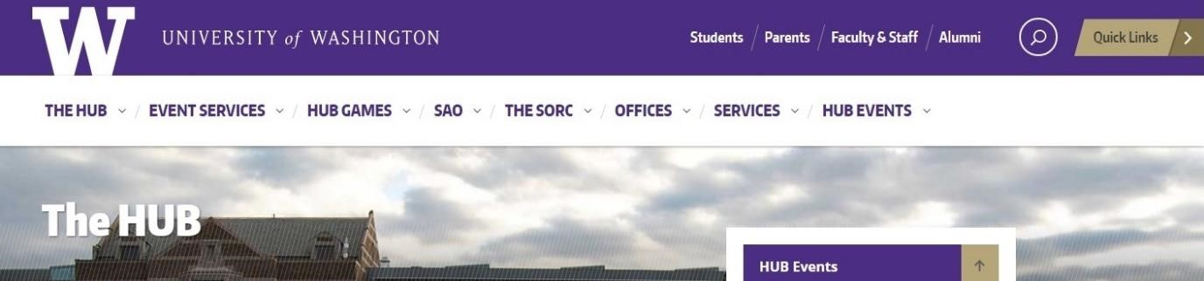
http://depts.washington.edu/thehub

Project Description
This website was named after the building of the student union, the website is made for all the activities of the student union and all what you need to know about the university including offices, restaurants, the different rooms in the HUB building and the activities in them. The SAO (Student activities Office) is a part of this website and building which encourage UW students to participate in student activities and student government as an excellent way to experience personal growth, meet new friends, and share common interests with other students, faculty and staff. The SAO includes RSO community (Registered Student Organizations) which helps students find activities registered for the academic year and search all their events through the RSO directory.

2.1.1 Functional Specifications
This list contains some of what the website offers for its visitors
*General Information
2.1.2.1 Information about the site: This is available in The HUB tab which includes general information about the building like directions, staff, and available jobs.
2.1.2.3 Search tab: User can search about any subject he/she wants.
*Student Activities Relevant
2.1.2.4 Information about the Student activities is found in SAO tab (student activity office) which helps the user find advisors for student activities, student activities news through RSO (Registered student organizations), and RSO event planning.
2.1.2.5 Events can be found in the HUB Events tab where user can know about different events in the HUB now, student activities fair and many other events.
2.1.2.6 Games in the HUB building is found in The HUB games tab where the user can know about different games available like tennis, bowling, and also tournaments.
*Non-Student Activities Relevant
2.1.2.2 User can know about offices available in the campus through the Offices tab.
2.1.2.7 Alumni In this tab user can find alumni stories and know about their life after university.
2.1.2.8 Faculty and Staff in this tab staff can find some services like
Human Resources: jobs.
UW libraries: it contains libraries catalogue and data.

Non-Functional Specifications
2.1.3.1 Performance: site performance to requests is very slow.
2.1.3.2 Usability: the site is user friendly with very good design.

Limitations
The site doesn’t have a direct page to group all students’ activities events, news and workshops, instead you have to search by date in RSO directory and go through numerous pages to find what you want.

2.2 Harvard University <Office of student Life> http://osl.fas.harvard.edu/home
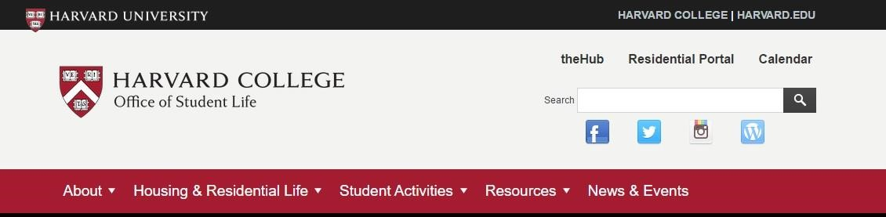

2.2.1 Project Description
This website is about The Office of Student Life, The Office supports Harvard’s distinctive residential House system and involvement outside the classroom providing opportunities for intellectual, social, and personal transformation. The Office of Student Life comprises two areas, primarily: Residential Life and Student Activities.
Student activities tab is a part of this website it helps students know about student activities in their university.

2.2.2 Functional Specifications
This list contains some of what the website offers for its visitors
*General Information
2.2.2.1 Information about the website is found in the About tab it contains information about People responsible for The office, Parents programs and information about the office.
2.2.2.2 Search tab: User can search about any subject he/she wants.
*Student Activities Relevant
2.2.2.3 Student Activities tab provide the visitors with student activities list their contacts, websites, event planning, annual registration and fundraising.
2.2.2.4 All the latest university’s news is found in the News and Events tab.
*Non-Student Activities Relevant
2.2.2.5 In the Resources tab user is provided with resources to develop personal, social, and intellectual growth at Harvard College. Included here are initiatives to support diversity and inclusion, address harassment and discrimination, and prevent hazing.

2.2.3 Non-Functional Specifications
2.2.3.1 Performance: site performance to requests is very fast.
2.2.3.2 Usability: the site is user friendly with very good design.

2.2.4 Limitations
The site doesn’t have a direct page to group all students’ activities events and news, instead you have to open student activities tab and find website of each student activity and visit it independently.

2.3. The University of Southern Mississippi

http://www.usm.edu/


2.3.1 Project Description
This website is for the University of Mississippi, it contains all information about university like academics, admissions, community and news.
Office of student activities is an important addition in this website which helps the visitors know about student activities in the university.
2.3.2 Functional Specifications
This list contains some of what the website offers for its visitors.
*General Information
2.3.2.1 Information about the website is found in About tab it provides the visitor with information about the university like its history and its mission.
2.3.2.5 Search tab: User can search about any subject he/she wants.
*Student Activities Relevant
2.3.2.2 Information concerning social life of students is found in Student Life tab like student health services, student conduct, residence life and Office of student activities.
2.3.2.3 Student activities information is found in Office of student activities tab which is a feature in student life list where visitors can find ambassadors of activities, list of registered student activities classified by type, and how to start one.
2.3.2.4 The latest news is found in the News tab.
2.3.2.6 Arts tab where user can find out about different activities like dance, music and theatre.
2.3.3 Non-Functional Specifications
2.3.3.1 Performance: site performance to requests is very fast.
2.3.3.2 Usability: the site is not very user friendly, as sections is not
very well classified.

2.3.4 Limitations
The limitation here is that user interface of the calendar of student activities events is not very attractive and the calendar is not directly found.

2.4 Summary

2.4.1 Functional Specifications

2.4.1.1 Essential Specifications
*General Information
*Student Activities Relevant

2.4.1.2 Non-Essential Specifications
*Non Student Activities Relevant

2.4.2 Non-Functional Specifications

2.4.2.1Essential Specifications
*Performance

2.4.2.2 Non-Essential Specifications
*Usability

2.4.3 Limitations
2.4.3.1 University of Washington
*Limitation➔ The site doesn’t have a direct page to group all students’ activities events, news and workshops, instead you have to search by date in RSO directory and go through numerous pages to find what you want.
*Our solution➔ all events, announcements will be gathered in one place (as posts) to make it easier for user to see and find them.

2.4.3.2 Harvard University
* Limitation➔ The site doesn’t have a direct page to group all students’ activities events and news, instead you have to open student activities tab and find website of each student activity and visit it independently.
*Our solution➔ all events, announcements will be gathered in one place (as posts) to make it easier for user to see and find them.

2.4.3.3 University of Southern Mississippi
*Limitation➔ the limitation here is that user interface of the calendar of student activities events is not very attractive and the calendar is not directly found.
*Our solution➔ Attractive interface and design and easily accessible posts.

3. Cost Estimate

Item | Estimated Cost
Item | US Dollars/Month | L.E./Month
1. Development Cost
1.1 Paying the Engineers | $ 410 | L.E. 3690
1.2 Paying the Programmers | $120 | L.E. 1080
1.3 Testing | $100 | L.E. 900
1.4 Documentation | $300 | L.E. 2700
1.5 Project Management | $330 | L.E. 2970
1.6 Cost risk | $50 | L.E. 450
Total | $ 1310 | L.E. 11790
2. Deployment Cost
1.1 Domain name of website | $ 1 | L.E. 9
1.2 Servers | $ 9 | L.E. 81
1.3 Networks | $ 8 | L.E. 72
1.4 Hardware devices | $ 8 | L.E. 72
1.5 Maintenance | $ 20 | L.E. 180
1.6 Advertising | $ 35 | L.E. 315
1.7 Cost risk | $ 35 | L.E. 315
Total | $ 116 | L.E. 1044
Total Estimated Cost | $ 1426 | L.E. 12834
Table 2: Cost Estimate

4. Feasibility Study
This feasibility study summarizes results of the analysis and evaluations of the project identifying if it is really feasible, cost-effective and successful.

1) The website will help students follow the events and workshops of the student activities and communicate with them. So our main goal is to help students get the most benefit from student activities and help them make their own mark in life without wasting their time.
2) The website will use available technology and tools (WAMP server, Git Hub). It will be finished before the deadline and with an appropriate budget and its cost will be suitable for all the clients.

3) The website will be viewed in all web browsers .It is an independent site and we will build it from scratch

5-Requirements Specifications

5.1-User Requirements (User Stories):
This section gives some information on the features that will be provided for the user by this website application.
5.1.1 Visitor Story:
A visitor, who doesn't have an account in LEAD website, can
5.1.1.1 View the posts in the home page (US-01)
5.1.1.2 Can search for specific student activity by its name (US-02).
Overall Priority: High.

Priority of feature available:
High: view posts in the home page, search for specific activity.

5.1.2 Student Story:
A Student, who have an account in our system, can
5.1.2.1 Sign up (US-03).
5.1.2.2 Log in (US-04).
5.1.2.3 View the posts in the home page (for students) (US-05)
5.1.2.4 Can search for specific student activity by its name (for students) (US-06).
5.1.2.5 Comment to the posts in the home page (US-07).
5.1.2.6 Update profile information (US-08).
5.1.2.7 Get notifications for his/her favorite activity (US-09).
5.1.2.8 Follow specific post (US-17).
5.1.2.8 Log out (US-18).
Overall Priority: High.
Priority of features available:
High: Sign up, sign in, get notifications, view home page.
Medium: write comments, update their profile information.

5.1.3 Admin of Student activity:
An admin for specific student activity can
5.1.3.2 Log in, admin log in, (US-10).
5.1.3.3 View the posts in the home page (US-11)
5.1.3.4 Can search for specific student activity by its name (US-12).
5.1.3.5 Comment to the posts in the home page (US-13).
5.1.3.6 Update activity information (US-14).
5.1.3.7 Write posts to publish an event of his/her activity (US-15).
5.1.3.8 Delete posts (US-16).
5.1.3.9 Log out (US-19).
Overall Priority: High.
Priority of features available:
High: sign up, log in, write post, add an event, and manage the activity page.

5.2 System Requirements (Use Cases)

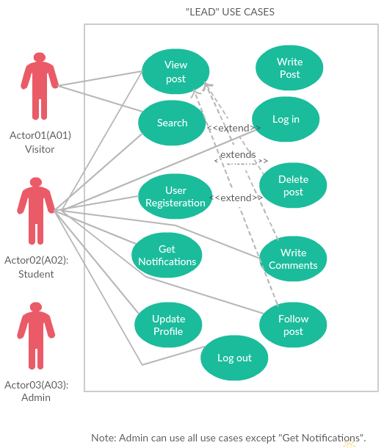
5.2.1 User Registration (UC-01)

Name: User Registration.
Identifier: UC-01.
Preconditions: The user must be connected to the internet.

Basic Course:
1. Use case begins when a visitor requests to sign up.
2. He/she starts by filling their information in the form for creating an account.
3. The system will make sure if the email entered hasn't already exist.
4-Use case ends by updating data then view home page.
Alternate Course A: invalid information (Another user is registered with the same e-mail).
Condition: The applicant has entered an e-mail that already exists in the data.
An error message will be shown tell the user the email he/she entered is already exist and he/she should enter another e-mail.
Alternate Course B: registration not completed because you don't enter all required information.
Condition: lack of information.
An error message will be shown and asked the user to complete the rest of information.
Post conditions: The user gets profile which contains his/her data.
Map to: US-03.

5.2.2 Log in
Name: Log in.
Identifier: UC-02.
Preconditions: The user should have an account in the system.
Basic Course:
1- The user will enter his/her email.
2- The user will enter his/her password.
3- Then he/she should click on "Log in" button.
4. The system will check for the user email and password if they are correct.
5- A Message will appear to verify the success of the log in.
Alternate Course A: invalid email.
Condition: The user has entered an e-mail that isn't in the data.
An error message will be shown tell the user the email he/she entered is not in the data he/she should register before.
Alternate Course B: wrong password.
Condition: The password doesn't match the email.
An error message will appear and asked the user to re-enter the password because it is wrong.
Post conditions: The user enter to the home page.
Map to: US-04.
5.2.3 Write post
Name: Write post.
Identifier: UC-03.
Preconditions: The user must log in and be an admin.
Basic Course:
1. Use case begins when an admin wants to write a post.
2. He/she starts to type his/her post.
3-Use case ends by clicking on "post" button then home page will appear.
Post conditions: The post will be added to the home page and activity profile where all users can see the post when they open home page.
Map to: US-15.

5.2.4 Get Notifications
Name: Get Notifications.
Identifier: UC-04.
Preconditions:
1- The user should log in to the system.
2- A new post of the user favorite types is added or a post that the user followed is updated/deleted.
Basic Course:
1. Use case begins when there is a new post of user favorite types is added or a post that the user followed is updated/deleted.
2- A notification will be sent to the user notification page.
3-User then clicks on the link to read it.
Alternate Course A: post has been removed.
Condition: when the user gets notification about specific post and the admin of that post delete it.
The notification will disappear and the user will get new notification of that the admin has deleted the post.
Post conditions: When the user read the notification, it will mark as read notification which may disappear after amount of new notifications are added.
Map to: US-09.

5.2.5 Write Comments
Name: Write Comments.
Identifier: UC-05.
Preconditions:
1- The user should log in to the system.
2- The user should open post page.

Basic Course:
1 The user sees the post and in the bottom there is text box to write the comment.
2- After writing the comment the user should click on "comment" button.

Post conditions: The post's comments will be updated.
Map to: US-07, US-13.

5.2.6 Follow post
Name: follow post.
Identifier: UC-06.
Preconditions:
1- The user should log in to the system.
2- The user should open post page.
Basic Course:
The user sees the post and if he wants to get notification for that post he/she should click on follow button in the post page.
Post conditions: The list of the user that consists of the followed posts will be updated in the database.
Map to: US-17.
5.2.7 Delete post
Name: Delete post.
Identifier: UC-07.
Preconditions:
1- The user should log in to the system.
2- The user should be an admin.
3- The user should open his/her post page.

Basic Course:
The user sees the post and click on "Delete" button.

Post conditions: The post will be deleted and a notification will be send to the users who follow this post.
Map to: US-07, US-13.

5.2.8 Search
Name: Search.
Identifier: UC-08.
Preconditions: The user should have internet access.
Basic Course:
1- Use case begins when the user clicks on the search bar.
2- The user will enter the student activity he/she wants it.
3- List of results of his/her search will appear to the user.
4-User then clicks on the result, he/she wants it, to see the student activity page.

Alternate Course A: invalid search.
Condition: The applicant has entered name of student activity which isn't in our system.
An error message will appear to tell the user that there are no results for his/her search.
Map to: US-02, US-06, US-12.

5.2.9 Update profile
Name: Update profile.
Identifier: UC-09.
Preconditions: The user should have an account in the system and log in.
Basic Course:
1- Use case begins when the user clicks on the "Update Profile" button.
2- The page will appear containing all the user information.
3- The user will change the information by entering the new information he/she wants to update.
4-User then clicks on the "Update" button.

Alternate Course A: invalid information.
Condition: The applicant has entered an e-mail that already exists in the data.
An error message will be shown tell the user the email he/she entered is already exist.
Post conditions: User information will be updated in the data.
Map to: US-08, US-14.

5.2.10 Log out
Name: Log out.
Identifier: UC-10.
Preconditions: The user must log in to the system.
Basic Course:
1. When the user wants to log out he/she should click on "Log out" button.
2. A message will appear to tell the user to come back to the site.

Post conditions: The system will treat the user like a visitor who doesn't have an account.
Map to: US-18, US-19.

5.2.11 View posts
Name: View posts.
Identifier: UC-11.
Preconditions: The user must connect to the internet.
Basic Course:
When the user sees the home page and wants to see specific post he/she should click on "Read more" button.

Post conditions: the system will open a new page that consists of the post.
Map to: US-01.

5.3 Non-functional Requirements
5.3.1 Easy to use (Nf1):
The system has simple interface that the user can use it easily.
Map to: all user stories.
5.3.2 Time for loading (NF2):
As the system is a website application, the reasonable time for loading the web page will be 1-2 sec.
Map to: all user stories.

6. High level plan

Iteration 1:
User Stories | Estimated Time (man/day)
1. Sign up | 14
2. Log in | 14
3. Profile | 11
4. Home | 3
5. Publishing posts | 6
6. Search | 6
7. Log out | 4
Total Time | 58

Iteration 2:
User Stories | Estimated Time (man/day)
1. Comments | 9
2. Update profile | 5
3. Send notifications | 6
4. Follow a post | 6
5. Delete posts | 6
Total Time | 32
Table 1: High Level Plan

6.1 User Stories Time Plan

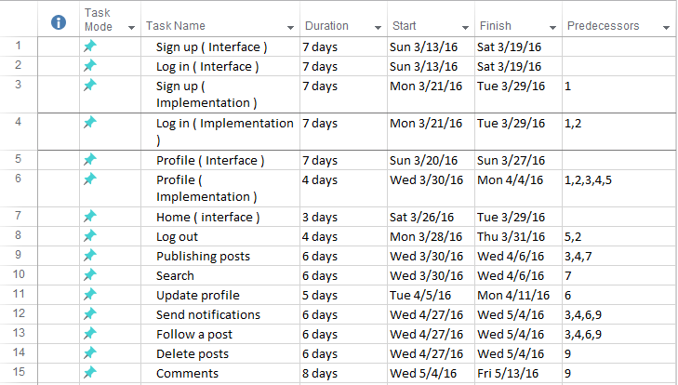

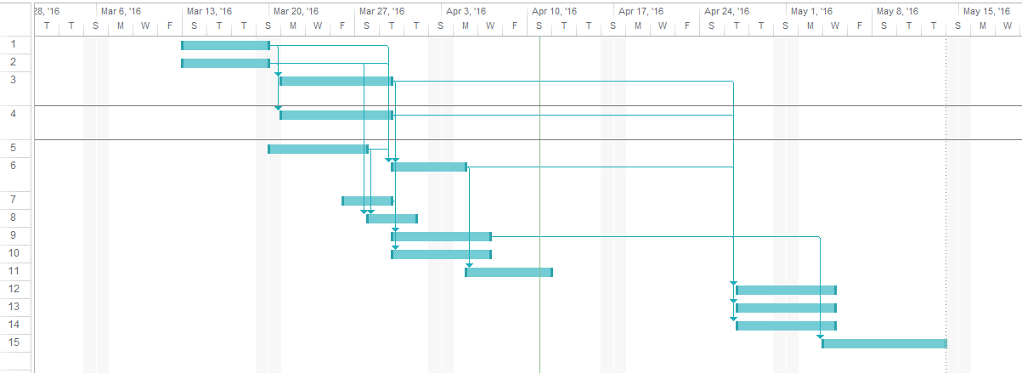

6.2 Staffing
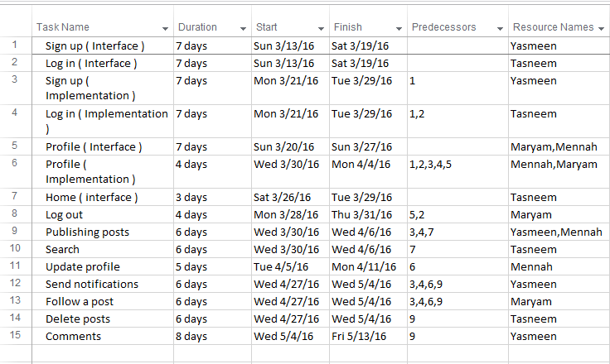

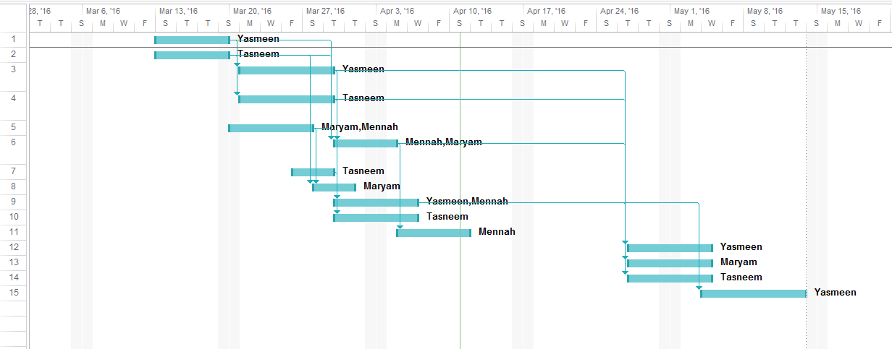

7. Supporting Information

Appendix A
Traceability Matrix

RID | 01 | 02 | 03 | 04 | 05 | 06 | 07 | 08 | 09 | 10 | 11 | 12 | 13 | 14 | 15 | 16 | 17 | 18 | 19
UC-01 |  |  | 
UC-02 |  |  |  |  |  |  |  |  |  | 
UC-03 |  |  |  |  |  |  |  |  |  |  |  |  |  |  | 
UC-04 |  |  |  |  |  |  |  |  | 
UC-05 |  |  |  |  |  |  |  |  |  |  |  |  | 
UC-06 |  |  |  |  |  |  |  |  |  |  |  |  |  |  |  |  | 
UC-07 |  |  |  |  |  |  |  |  |  |  |  |  |  |  |  | 
UC-08 |  |  |  |  |  |  |  |  |  |  |  | 
UC-09 |  |  |  |  |  |  |  |  |  |  |  |  |  | 
UC-10 |  |  |  |  |  |  |  |  |  |  |  |  |  |  |  |  |  |  | 
UC-11 |  |  |  |  |  |  |  |  |  |  | 
NF1 |  |  |  |  |  |  |  |  |  |  |  |  |  |  |  |  |  |  | 
NF2 |  |  |  |  |  |  |  |  |  |  |  |  |  |  |  |  |  |  | 

Appendix B
Dependability Matrix

RID | US1 | US2 | US3 | US4 | US5 | US6 | US7 | US8 | US9 | US10 | US11 | US12 | US13 | US14 | US15 | US16 | US17 | US18 | US19
US-1
US-2
US-3 |  |  |  | 
US-4 |  |  |  |  |  |  |  |  |  |  |  |  |  |  |  |  |  | 
US-5
US-6
US-7 |  |  |  |  |  |  |  |  | 
US-8
US-9
US-10 |  |  |  |  |  |  |  |  |  |  |  |  |  |  |  |  |  |  | 
US-11
US-12
US-13 |  |  |  |  |  |  |  |  | 
US-14
US-15 |  |  |  |  |  |  |  |  |  |  |  |  |  |  |  |  | 
US-16 |  |  |  |  |  |  |  |  | 
US-17 |  |  |  |  |  |  |  |  | 
US-18
US-19

